Learning Management System
In-House Pilot
1. Background
The note is about having a unified Learning Management System (LMS) — for the entire organisation -one platform to host technical and behavioural training for the workforce, track individual progress with assessments being the integral part of the process.
As a first step, an in-house LMS has been built as a standalone pilot . The same is proposed to be deployed as a test case on the inhouse server system (the infrastructure shall be required from Corporate Infocom) and scaled organisation wide.

2. Current Status — Pilot Already developed
- A standalone pilot LMS has already been developed in-house by Sh. Nitin Dua, CM (Prog.) with inputs from Strategy Group.
- It includes a working dashboard showing an individual's training progress and assessment scores (currently populated with dummy data for testing).
- A second dashboard has also been built to show how this progress can flow to an employee's controlling officer.
- The pilot is ready to be mounted on Data Centre infrastructure with some dummy trainings and assessments .
3. Objective
To provide a single platform where:
- Technical and behavioural training for all executives can be hosted, assigned and tracked.
- Every training carries a built-in assessment, not a separate, disconnected test.
- Progress shall be visible both to the individual and to their controlling officer.

4. Key Features (Pilot and Planned)
- Course authoring with one or more sections, each with an attached quiz and automatic scoring.
- Support for SCORM-based courses, as well as video, PDF, HTML and image-based content.
- Individual dashboard — courses completed, in progress, and assessment scores.
- Controlling officer dashboard — team-wide progress at a glance.
- Device-agnostic access (laptop, tablet, mobile) — planned for the final rollout stage.

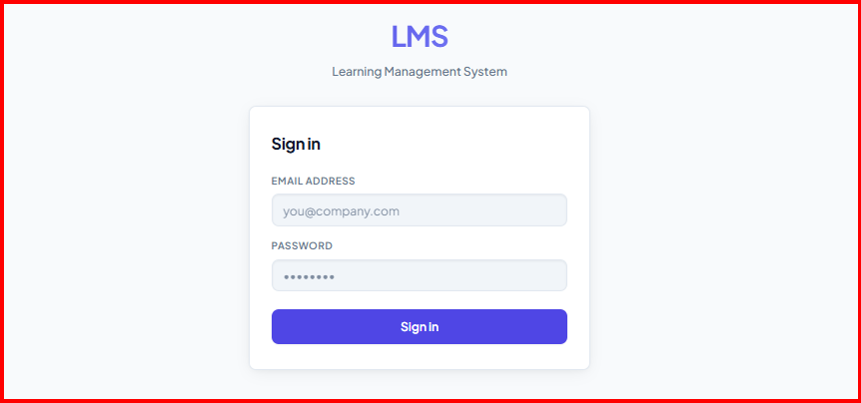

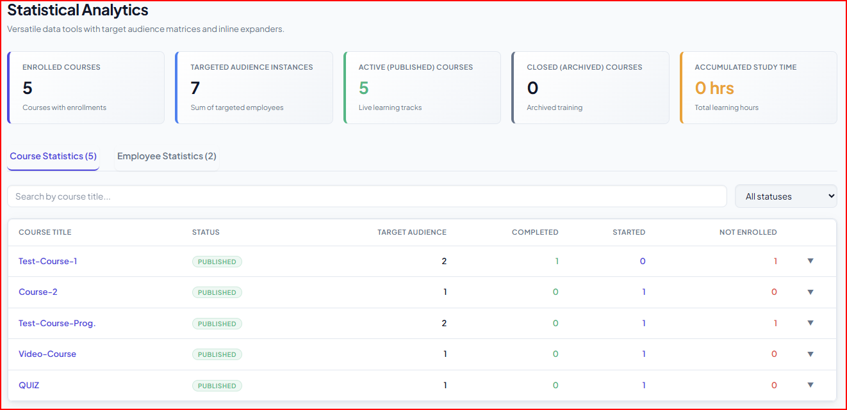

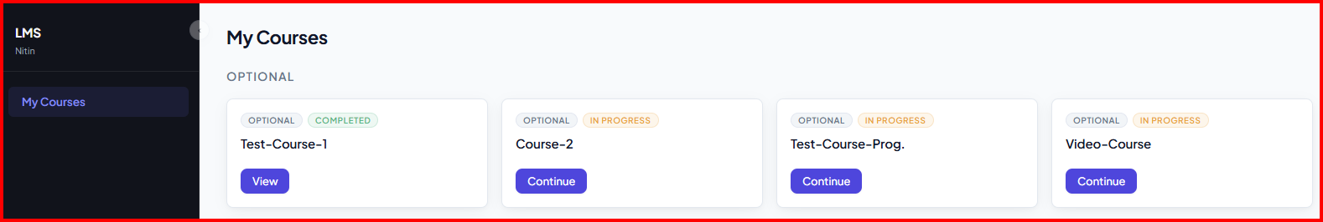
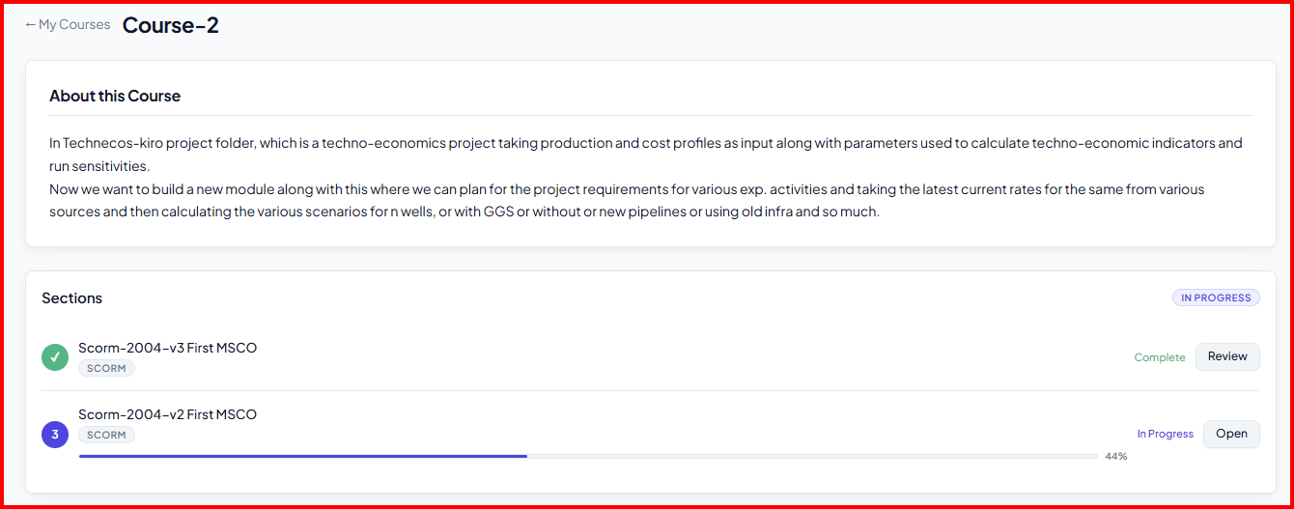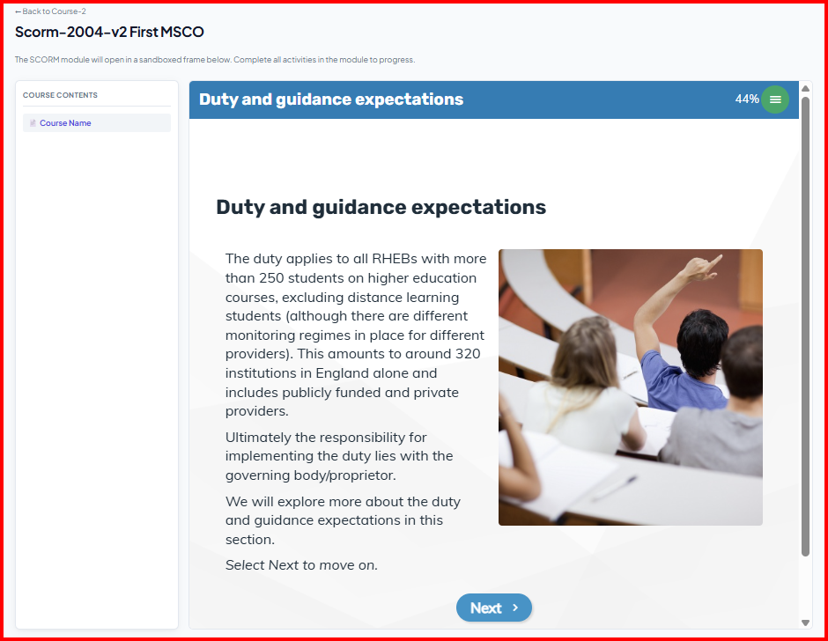

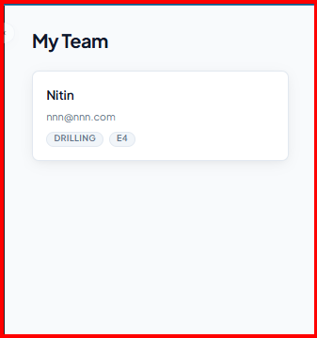
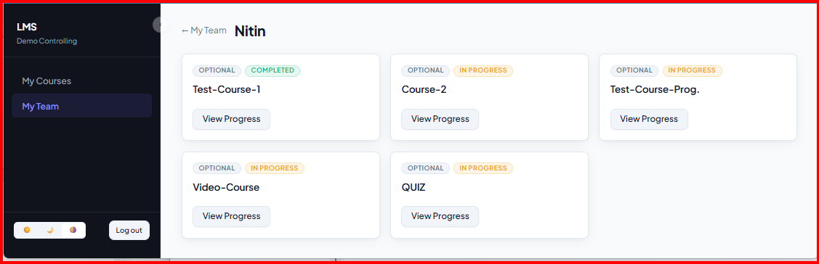

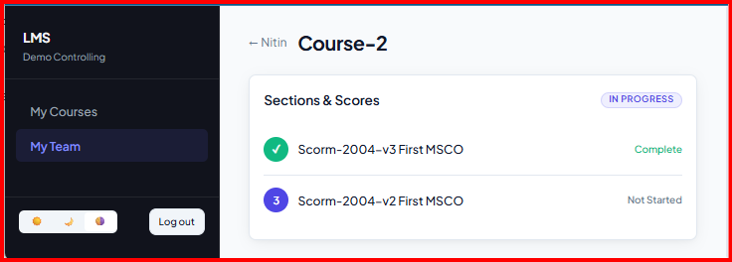

5. Parallel Activities:

- Formation of a Execution Committee with following members:

- Sh. Ajay Sahoo. CGM(HR), HOI-ONGC Academy, Team lead (Coordination with all training imparting institutes of ONGC)
- Sh. Mahesh Kumar, CGM(HR), ICE-HR Team lead for SAP integration
- Sh. Nikhil Dahat, GM(IE)-Strategy Group-Member
- Chunuram Hembram, GM (E&T)- Data Centre Group- Corporate Infocom-Member
- Satyajit Das, GM (Programming) – Corporate Infocom-Member
- Sh. Nitin Dua, CM (Programming)-Database Group-Vadodara, Member- Developed the LMS pilot.
- Sh. Anshul Tiwari, CE(P), Strategy Group, Member

Responsibilities of the Execution Committee:

- Validation of the pilot developed.
- Providing on premises IT resources/ infrastructure for mounting the LMS.
- Uploading of the Content provided by ONGCA and ATI-GOA.
- Ensure all the functionalities like running of the content, assessments, GAP analysis etc for successful implementation of the LMS system.
- Rolling out the system organisation wide.
- Maintaining and day to day troubleshooting the LMS system post implementation organisation wide. Responsibility: ONGC Academy.

- Uploading of GT training material in LMS format by ONGC Academy for E1 to E5 level executives.

- Identification of mandatory and desirable training courses for E1 to E5 level executives all disciplines by interacting with SME’s/ training imparting institutes . – Responsibility ONGC Academy

- ONGCA and ATI GOA to interact with SME’s and finalise the list of such Technical trainings for each discipline and curate above training courses (E1 to E5) along with assessments and provide the content to the Execution committee.

- For E6 and L1, L2 and L3 roles ONGCA and ATI GOA to curate the managerial/ Behavioural courses along with Assessments for the six behavioural competencies as being assessed through ADC’s and provide the content to execution committee.

Execution committee to upload the above courses and achieve all the functionality of LMS for these courses as provided by Training Institutes. Training institutes to work in close collaboration with the Execution committee for successful integration. Responsibility: Training Institutes and ONGC Academy.

6. Basic Flow
- ONGCA and ATI GOA gives the training content to Execution committee and they upload the content in the LMS
- A quiz is attached to each section, to be completed before moving ahead.
- The learner completes the section and its quiz; the score is recorded automatically in LMS and SAP also.
- The dashboard updates for both the learner and their controlling officer.

7. Why an In-House System
- No initial cost and no recurring per-employee licence cost, unlike a purchased product.
- Full control over data — everything stays inside our own Data Centre.
- Free to support any content type, rather than being limited to what a vendor allows.

8. Basic Requirements for the Testing Stage
- A modest server/VM’s allocation from the Data Centre to mount the pilot — one or two hosts would be sufficient at this stage.
- Access for approximately 10 users for the next test phase with appropriate hardware initially around 500 GB of Storage.
- A short list of test content — a few freely available training videos and PDFs — to run through the system.

8. Implementation Plan
Stage | What Happens
Stage 1 | Validate the existing pilot and mount it on Data Centre hardware; test with dummy data.  Target: within 15 days of resources being made available.
Stage 2 | Open the system to about 10 users with real test content on better infrastructure;  Validate the dashboard, progress reporting, and controlling officer view.
Stage 4 | ONGCA and ATI Goa to curate course for uploading in LMS.
Stage 5 | Scale to the full organisation.
Stage 6 | Make the system device agnostic, make it accessible from laptop, tablet and mobile.

Result and Responsibility:
To test the prototype model on a small scale, then scale it for organisation wide usage, monitor the stability and health of the module. Once fully operational to maintain and upgrade as and when required.
Responsibility: ONGC Academy

10. Benefits
- One place for all workforce training, instead of scattered content with no consistent tracking.
- Transparent, near real-time progress visible to management through the reporting chain.
- No recurring licence cost — meaningfully lower cost over the long run than a purchased product.

